EGR2312 Lab Experiment N°10
W beams and S beams

Introduction
Beams are an essential part of the structural safety of buildings. They are used to transfer and distribute loads (you can see them everywhere on campus, see figure 1). Their properties differ depending on their cross-sectional area. In this experiment, we will simulate the loading of two different shapes of beams using ANSYS.

Figure 1. Beams on campus
Procedure
We will work with two different beams with two different cross-sections: the W-shape beam W200x52 and the S-shape beam 250x52.
Refer to Appendix C in your textbook for the dimensions of the cross-section of each one. We will set a length of 1m for each beam.
We will simulate the case where a beam is fixed to a wall on one end and connected to other beams on the other end. The beams will be supporting a distributed load across their upper flange. Select a value for your forces and keep them the same for all three beams.
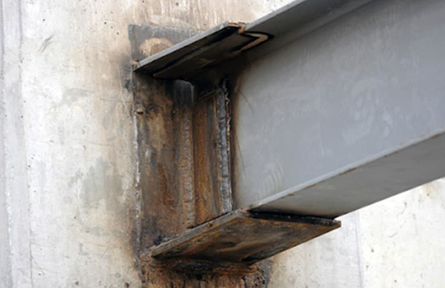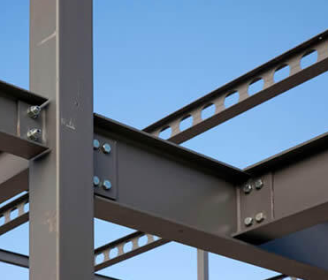
The other end of the beam is a connected to other beams
One end of the beam is a fixed support

Figure 2. Loading conditions
Your task is to load the three beams as described above and compare them to conclude which shape can support more loads.
- For each beam, specify the dimensions you computed (using Appendix C) and using the following the sketch below:
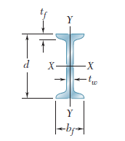
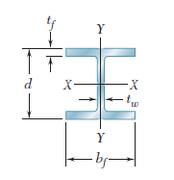

Figure 3. Dimensions sketch
Dimension (mm) | W-shape beam | S-shape beam
t_{f}
t_{w}
b_{f}
d

- When solving your model, what variables do you have to insert to your solution to monitor the behavior of the beam?
- Add these variables (hint: you have to insert three variables) and record their values for each beam. Report your results in a table.
- Compare the W-shape and S-shape Which type of beam is stronger? Why?

